**STRUCTURE DIAGRAM FOR WEDDING PLAN**

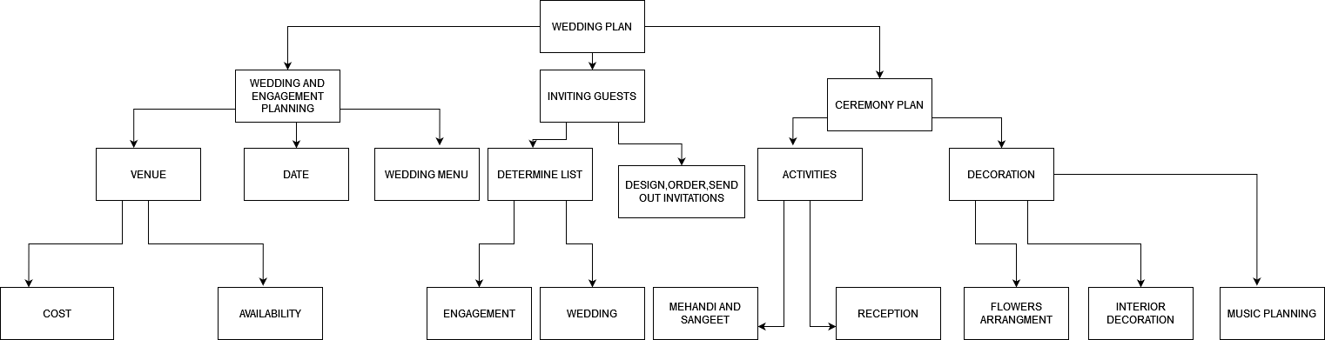

**FLOWCHART FOR WATCHING A MOVIE**

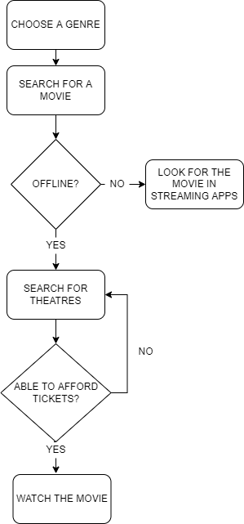

**STRUCTURE DIAGRAM AND FLOWCHART FOR WRITING A BOOK**

